Cyberball User Manual
May 2026—Version 6.0.0

Using Cyberball 3
GitHub 3
Website 3
Create New 3
Human Settings 4
CPU Settings 5
Gameplay Settings 8
Export Settings 9
Load Presets 10
‘Presets’ Tab 10
‘Your Games’ Tab 11
‘Load File’ Tab 11
Help 11
FAQs 11
Manual 11
Qualtrics 11
Setup 12
Data Output 14
Data Fields Setup 14
Data Field Descriptions 17
Embedded JavaScript 17
Downloading Results 19

Using Cyberball
Cyberball is a psychological research game that is used to test participants in simulated social scenarios. The two main ways to interact with Cyberball are the website and Qualtrics. The website is used to build game configurations or use published presets which dictate how Cyberball will behave. A configured game or published preset is able to be embedded into a Qualtrics survey, where it can automatically record data. The data can be exported from Qualtrics if desired.

GitHub
This section will explain the basics of how to interact with GitHub for a non-technical user. If you understand the usage of Git and GitHub, then you can skip this section of the manual.
Git is a version control system often used in software systems. It keeps track of changes to files in small “commits”. This allows storing the full history of the software development process.
GitHub allows for two different ways of contributing code if you want to make changes to Cyberball. You can either create an issue or pull request on the official Cyberball repository, or you can fork the repository to create your own version. The official Cyberball repository does not have full-time maintainers, so for time-sensitive issues it may be in your best interest to create a fork with the changes you want.
If your interest is in using the most recent version of Cyberball, all you need to do is download the code from the main repository or go to the tags on GitHub and find a version that you are looking for. The most recent version at the creation of this document is version 6.0.0.

Website
The website is a straightforward way to build game configurations, preview a game, and export the settings. On the home screen, you can begin building a new game configuration by selecting “Create New”, use one of the published presets by selecting “Load Preset”, or receive further assistance by selecting “Help”.

Create New
The configuration builder allows you to customize visuals and mechanics of Cyberball before saving the changes in your preferred format. The configuration panel is navigated using the arrows in the top corners to navigate between the human (participant) settings, the CPU settings, the general gameplay settings, and the export options—in that order.
All the settings and pages of the configuration builder are described in detail here. At any point during the configuration of a game, select the “Preview Game” button to refresh the lefthand side to reflect your current configurations of a Cyberball game.
Click any “?” buttons on the pages for a quick clear explanation of the correlating setting.

Human Settings
There are a few settings available to change for the participant. This includes the display name, further customization of the character, and the leave game options for the participant.
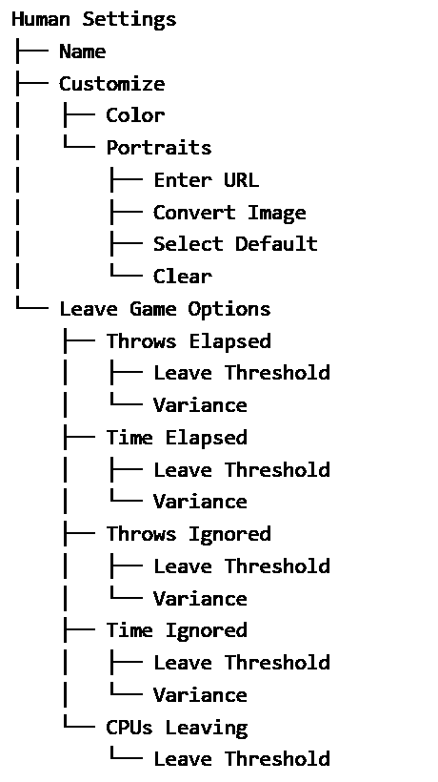
Human Settings Hierarchy Diagram
The name is the display name of the participant’s character during the Cyberball game which will replace ‘Player 1’ if changed.
The customization option allows the ability to change the inside color of the participant’s character or add a portrait that appears below the participant’s character.
A portrait is added by providing a valid URL to the image for it to appear. This feature does not support all URLs in the current state. An image stored inside Qualtrics or any publicly available direct URL to an image should work with this feature. A button to convert a downloaded image to a usable URL is provided in the settings. Also, a list of default portraits is provided inside Cyberball that are guaranteed to work if that is a suitable alternative. The “Clear” button will remove the portrait from the participant’s character.
The leave game options provide the ability to let the participant choose to leave the game early based on a set threshold. If the threshold is met, a “Leave” button will appear in the bottom right corner to give the participant the option to leave the game. This button will stay present for the participant for the remaining gameplay until the game officially ends based on a game end condition. You can change the variance for each option to allow a deviation away from the set threshold. For example, for the Throws Elapsed option, a variance of 2 means the participant is shown the “Leave” button +/- 2 throws from 10 throws (the button will appear somewhere between 8 to 12 throws).
A description for each provided leave game option:
- Throws Elapsed
  - the total number of throws between the participant and CPUs
- Time Elapsed
  - how many seconds the game is played
- Throws Ignored
  - the total number of throws between only the CPUs in a row
- Time Ignored
  - how many seconds the CPUs spend throwing to each other
- CPUs Leaving
  - the total number of CPUs that must ‘leave’ the game

CPU Settings
There are a few settings available to change for the CPUs. This includes the display name, further customization of the character, how long to take to throw and catch the ball, how often others are thrown to, and the leave game options.
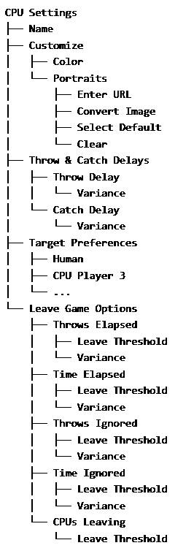
CPU Settings Hierarchy Diagram
The top of the settings has a scrollable selection bar to select between the different CPUs to change each of their settings independently of each other. These buttons are labeled as “Player 2”, “Player 3”, etc. The “Add CPU” and “Remove CPU” buttons will increase or decrease the number of CPUs in the game which will reflect in the settings and will reflect in the preview after clicking “Preview Game”. The rest of this section will describe how to change a single CPU’s settings, Player 2.
The name is the display name of the CPU’s character during the Cyberball game which will replace ‘Player 2’ if changed.
The customization option allows the ability to change the inside color of the CPU’s character or add a portrait that appears on the outside of the CPU’s character.
A portrait is added by providing a valid URL to the image for it to appear. This feature does not support all URLs in the current state. An image stored inside Qualtrics or any publicly available direct URL to an image should work with this feature. A button to convert a downloaded image to a usable URL is provided in the settings. Also, a list of default portraits is provided inside Cyberball that are guaranteed to work if that is a suitable alternative. The “Clear” button will remove the portrait from the participant’s character.
The throw and catch delays determine how long, in seconds, the CPU will wait before throwing or after catching the ball before making a throw themselves. You can change the variance for each option to allow a deviation away from the set threshold. For example, for the Throw Delay option, a variance of 1 second from 3 seconds means the CPU will take between 2 to 4 seconds to throw the ball.
The target preference settings let you control how frequently a CPU throws the ball to the participant and other CPUs and is represented as percentages. You can configure preferences explicitly to influence social dynamics within the game, such as inclusion or ostracism. These preferences must add up to 100% otherwise Cyberball gives a warning before proceeding and may not work as intended.
The leave game options provide the ability to let the participant choose to leave the game early based on a set threshold. If the threshold is met, a “Leave” button will appear in the bottom right corner to give the participant the option to leave the game. This button will stay present for the participant for the remaining gameplay until the game officially ends based on a game end condition. You can change the variance for each option to allow a deviation away from the set threshold. For example, for the Throws Elapsed option, a variance of 2 means the participant is shown the “Leave” button +/- 2 throws from 10 throws (the button will appear somewhere between 8 to 12 throws).
A description for each provided leave game option:
- Throws Elapsed
  - the total number of throws between the participant and CPUs
- Time Elapsed
  - how many seconds the game is played
- Throws Ignored
  - the total number of throws between only the CPUs in a row
- Time Ignored
  - how many seconds the CPUs spend throwing to each other
- CPUs Leaving
  - the total number of CPUs that must ‘leave’ the game

Gameplay Settings
There are a few settings available to change for the gameplay. This includes the game end condition, game over display settings, customization of the ball, and the scheduler.
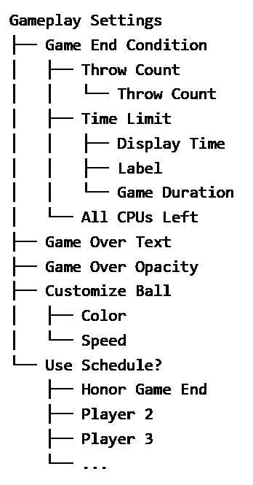
Gameplay Settings Hierarchy Diagram
The game end condition settings allow you to choose how the game will end. The three conditions to choose from are Throw Count, Time Limit, and All CPUs Left. These conditions all have different settings and only the selected game end condition is how the game will end.
A description for each provided game end condition:
- Throw Count
  - game concludes after a specific number of throws designated by the Throw Count setting

- Time Limit
  - game concludes after a specific number of seconds designated by the Game Duration setting
    - Display Time and Label settings allow the participant to see how much time is left
- All CPUs Left
  - game concludes after all CPUs leave the game based on previously configured leave conditions
The game over settings specifies what the participant will see when the game ends. The Game Over Text setting appears centered in the game after the game end condition is met, and the Game Over Opacity allows adjustment of the background transparency behind the text. You can set opacity from 0% (completely transparent) to 100% (completely opaque).
The ball customization settings allow you to change the inside color of the ball and the speed of the ball. The speed setting changes how long it takes for the ball to travel to another player in seconds. So, a higher value indicates a higher speed in the game.
The schedule settings allow you to have detailed control over the throwing patterns of CPUs in Cyberball. This option is particularly useful in controlled experiments to create a specific social dynamic.
The scheduler works by providing a comma-separated throwing sequence for each CPU to predetermine their ball throws. A sample schedule for ‘Player 2’ is provided: 3, 13, 1, 3, 3. The numbers indicate which players the CPU throws to. ‘1’ means ‘Player 1’ (participant) and ‘3’ means Player 3 (CPU). ‘13’ means that ‘Player 2’ will throw to ‘Player 1’ and ‘Player 3’ in their first 2 throws with a randomized order. So, in this example, ‘Player 2’ throws to ‘Player 3’ first, then to ‘Player 1’ or ‘Player 3’, then to the one it did not throw to, then to ‘Player 1’, then to ‘Player 3’ two more times before the schedule is over, with 6 total throws.
The Honor Game End setting only appears with the selection of the Throw Count game end condition and if selected, the schedule will be shortened to match the total number of throws set.

Export Settings
There are a few options available to export or save the game created.
A description for each provided button:
- Open Game Preview
  - opens the current game in a new tab
- Save Preset
  - saves the current configuration on your browser under the “Load Presets” option on the “Your Games” tab
- Download Game
  - downloads a .txt that contains all the configurations for the game, this .txt file is loadable under the “Load Presets” option on the “Load File” tab
- Download QSF
  - downloads a .qsf file that contains all the defaults to load and collect data in Qualtrics, this .qsf file is a template for inserting the embedded code the Cyberball Configuration Builder created for the Cyberball game the researcher designed
- Copy Embed Code
  - copies the HTML used to embed Cyberball into Qualtrics
- Copy Game URL
  - copies the URL of the Cyberball game that is sharable
A Cyberball game URL is usable on any browser, however in-game data collection is currently only available through Qualtrics.

Load Presets
The presets panel allows you to use published presets, load saved configurations from your browser, and load .txt files that contain Cyberball configurations.

‘Presets’ Tab
The ‘Presets’ tab contains all the pre-made Cyberball configurations which are able to be used or edited. The three presets provided are an ostracization game, an inclusion game, and a slow player game.
A description for each provided preset:
- Ostracized Game
  - participant will receive the ball twice towards the beginning of the game and then never again
- Inclusion Game
  - participant will receive the ball throughout the game approximating to roughly 33% of the time

- Slow Player Game
  - one computer-controlled player will hold onto the ball 16 seconds before throwing

‘Your Games’ Tab
The ‘Your Games’ tab contains any configurations saved on your local device through the ‘Save Preset’ button. Be aware that the presets saved in ‘Your Games’ are cached using local storage and clearing your browser’s cache will cause the preset to be removed. Each saved game displays the title and description you wrote and an ability to remove the game by clicking ‘X’.

‘Load File’ Tab
The ‘Load File’ tab allows you to load a configuration saved by downloading a .txt file as described above in the Export Settings.

Help
The help section provides quick access to support and documentation to aid you to navigate common issues and gain a deeper understanding of Cyberball.

FAQs
The FAQs address common questions and typical challenges you might encounter while working with Cyberball. It covers issues such as:
- What is Cyberball?
- Customizations in Cyberball
- Clarification of the Portrait Feature
- Export Settings
- Saving Presets
- Loading Files

Manual
Also, the help section includes a direct link to a PDF version of this Cyberball User Manual by clicking the “Manual” button. This manual comprehensively covers all aspects of the user interface, gameplay configurations, and Qualtrics integration.

Qualtrics
As mentioned before, Qualtrics is an easy way to administer Cyberball games and autonomously collect data on game sessions. The code and environment needed are often case sensitive, and it may be best to copy what is detailed below before attempting to make any changes.

Setup
The steps to add a Cyberball game to a Qualtrics survey are quite simple.
- Once a Qualtrics survey is set-up, identify where you want to add the embedded game.
- Click ‘Add new question’ and select ‘Text/Graphic’.
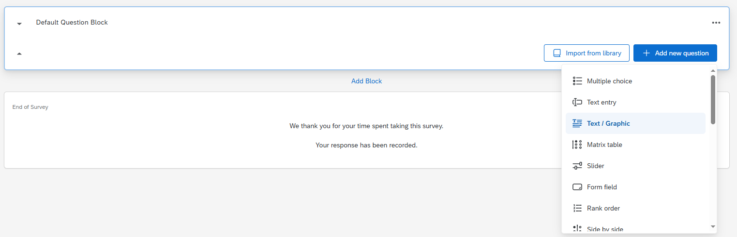
- Click on the default text in the question box, this should open the editor.
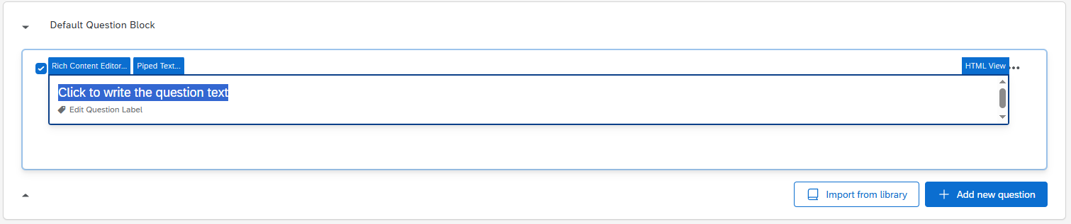
- Click on ‘HTML View’ in the top right of the text editor.
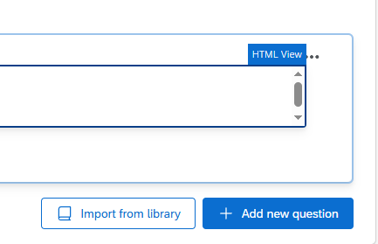
- Paste the embedded game data from the configuration website (“Copy Embed Code”). Or copy the following, replacing the URL with your custom game URL:
<iframe id="cyberball" width="100%" height="580" src="https://cyberball.osu.edu/#game?settings=..."></iframe>
- Click back into ‘Normal View’. The embedded game should be visible.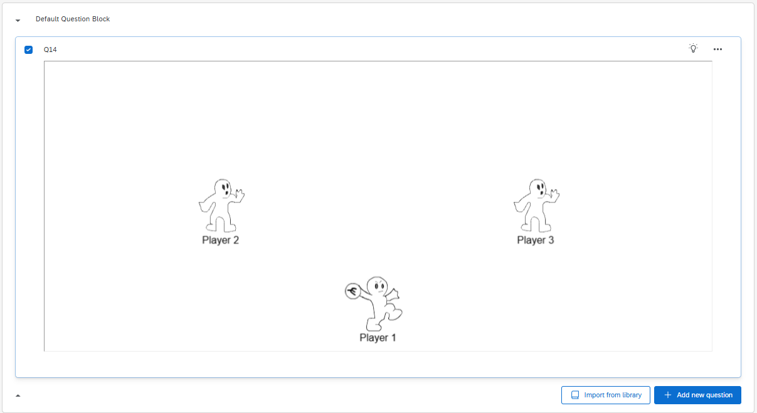
It is important to note that once a game is embedded, it is difficult to reopen the editor. To do so, hover over the game. You should see a gray border appear. Click on the bottom of this.
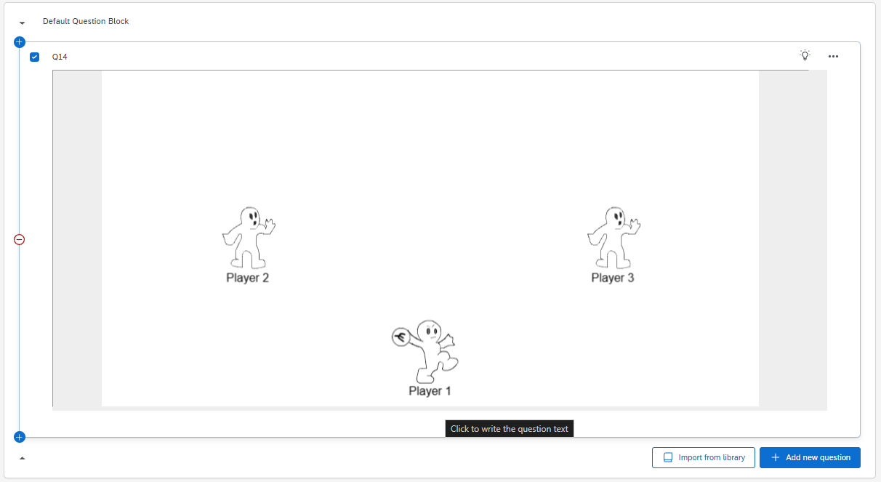
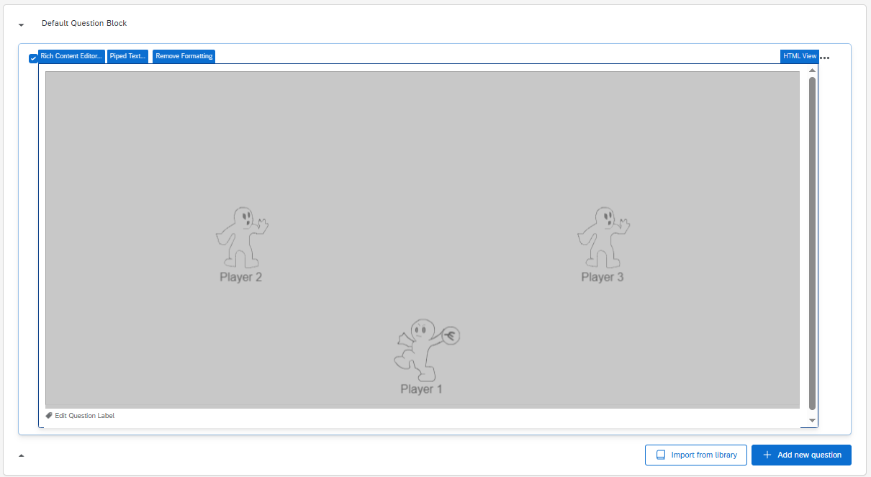
If you are unable to reopen the editor for any reason, you should be able to quickly delete and re-add the question using the steps shown before.

Data Output
After a Cyberball game is embedded into Qualtrics, you must add the embedded JavaScript and custom data fields to the survey to collect the data from the game. This data includes a log of all game events, timings, and more. After a published survey is set-up using the instructions below and has recorded responses, you can download the data in many different formats. Another alternative to following the instructions below is to download the provided .qsf file on the Export Settings page and import them. This link is a tutorial from the Qualtrics website.

Data Fields Setup
This section is critical as without data fields, there will be no game data collection saved by Qualtrics. This section is case-specific so be sure to check capitalization.
- Click on ‘Survey flow’ on the left control panel.
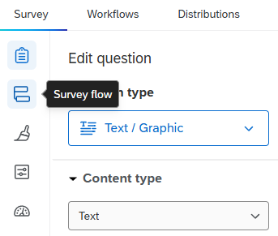
- Click ‘+ Add a New Element Here’ and select ‘Embedded Data’.
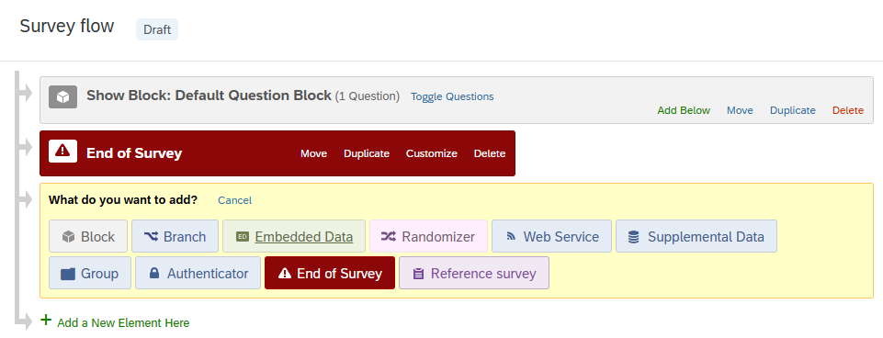
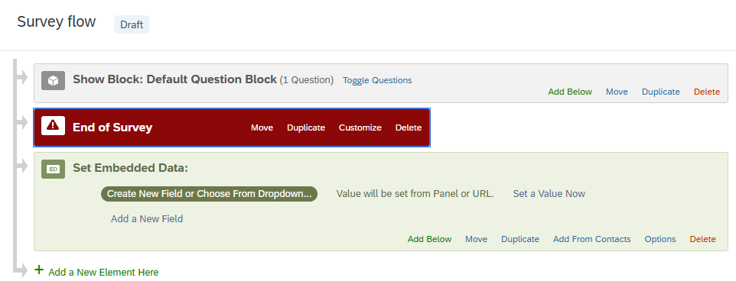

- The following fields need added exactly as typed as the fields are case and character specific.
  - game_log
  - throws_formatted
  - Player_1_to_Player_2
  - Player_1_to_Player_3
  - Player_1_to_Player_4
  - Player_2_to_Player_1
  - Player_2_to_Player_3
  - Player_2_to_Player_4
  - Player_3_to_Player_1
  - Player_3_to_Player_2
  - Player_3_to_Player_4
  - Player_4_to_Player_1
  - Player_4_to_Player_2
  - Player_4_to_Player_3
  - total_throws
  - player_may_leave
  - total_time
- Also, it is a good idea to add a Condition field that you manually set to match your game type. If you want, you can set other fields to be certain data types, but this is optional.
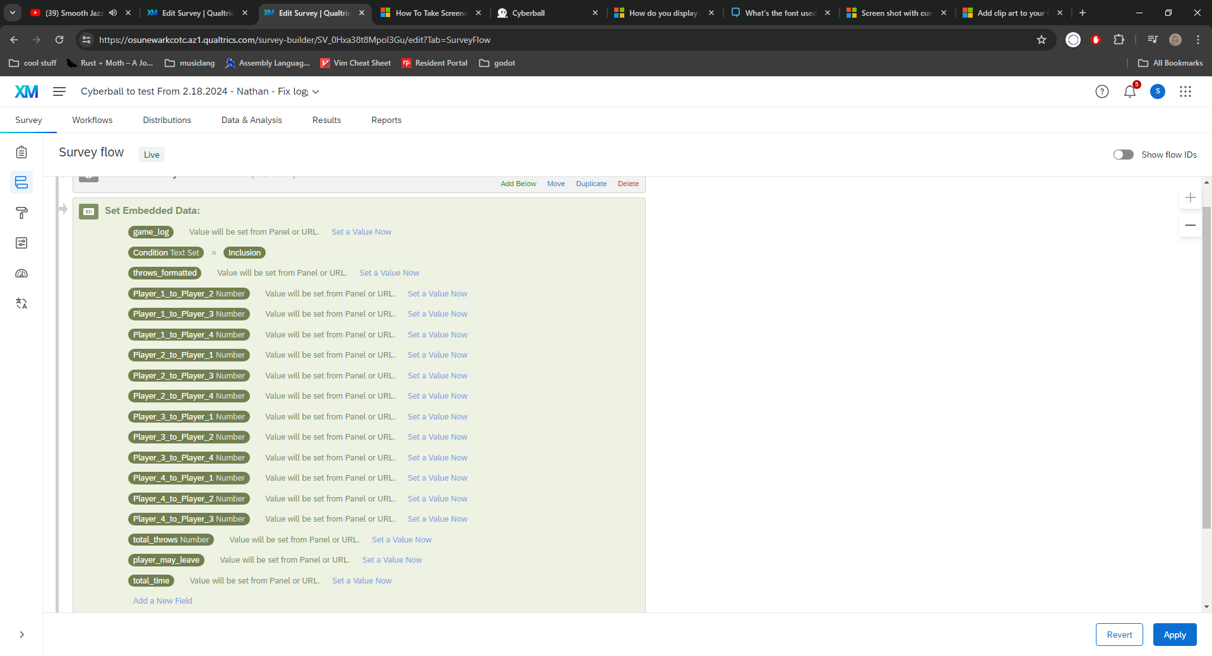

Data Field Descriptions
- game_log
  - the full event list of what happened in the game and when
- throws_formatted
  - a 2D array of throws from any player to any other player
    - arr[player_A - 1][player_B - 1] is the number of throws from A to B
    - the human player is always Player 1 and therefore index 0
- Player_A_to_Player_B
  - number of throws from player A to player B
    - limited to first four players
    - pulled out of throws_formatted for easier access and use
- total_throws
  - total number of throws from anyone to anyone in the game
- player_may_leave
  - when in the game the player is given the option to leave
- total_time
  - total duration of the game

Embedded JavaScript
Once a Cyberball game is embedded and data fields are set-up, the last step is adding the embedded JavaScript.
- Click on the Qualtrics survey question containing the embedded game.
- On the question, right click and select ‘</> Add JavaScript’ or click ‘</> JavaScript’ on the left.
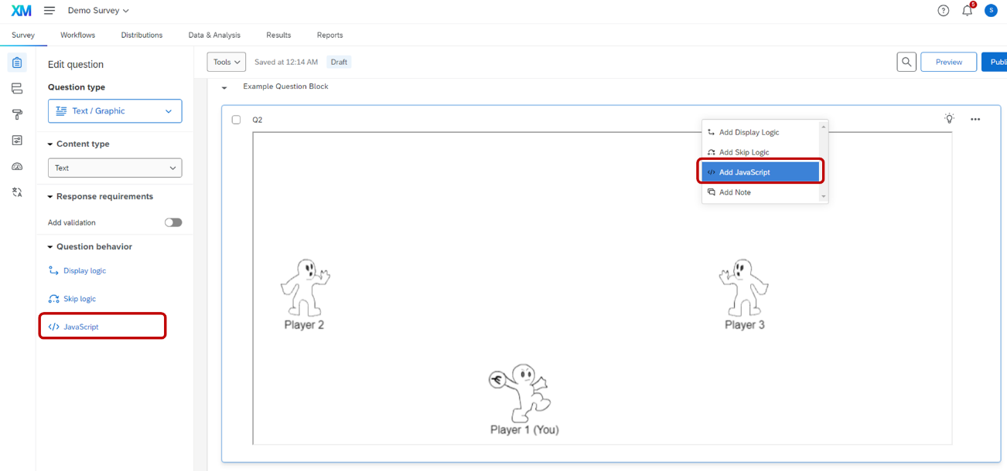
- This pop-up window should appear.
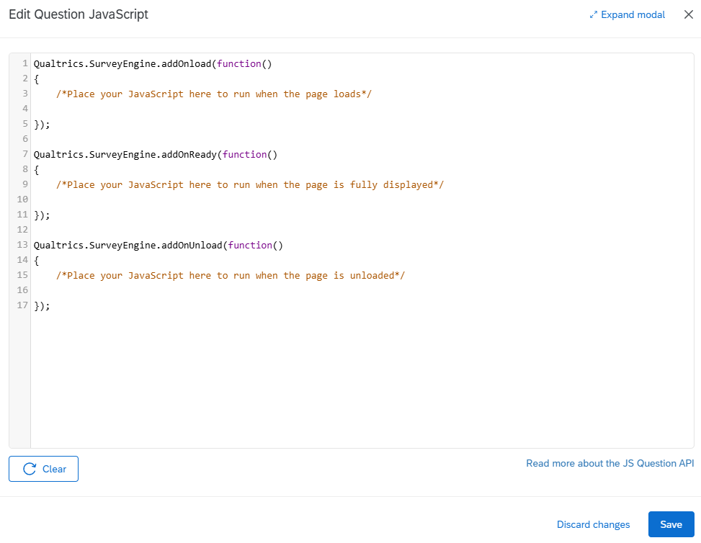
- Paste the following in the pop-up window.
Qualtrics.SurveyEngine.addOnload(function() {
this.hideNextButton();
});

Qualtrics.SurveyEngine.addOnReady(function() {
let that = this;

function handleSurveyMessage(msg) {
// Ignore anything that isn't our game data
if (!msg.data || typeof msg.data !== 'object') return;
if (!msg.data.game_log) return;

for (const [key, value] of Object.entries(msg.data)) {
if (key === "player_throws_list") {
for (const [throwPath, numThrows] of Object.entries(value)) {
Qualtrics.SurveyEngine.setEmbeddedData(throwPath, numThrows);
}
} else {
Qualtrics.SurveyEngine.setEmbeddedData(key, JSON.stringify(value));
}
}

setTimeout(() => {
that.clickNextButton();
}, 3000);
}

window.addEventListener('message', handleSurveyMessage);
});
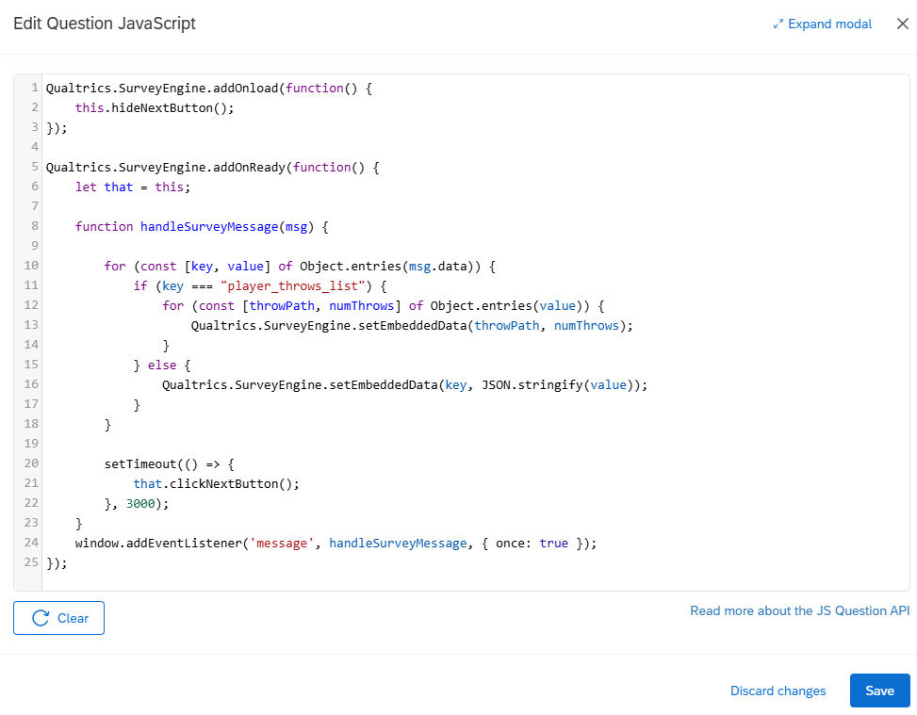
- Click ‘Save’ in the bottom right of the pop-up.

Downloading Results
- Click on ‘Data & Analysis’ at the top.
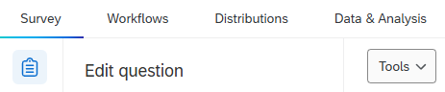
- Hit ‘Export & Import’ on the right, then select ‘Export’.
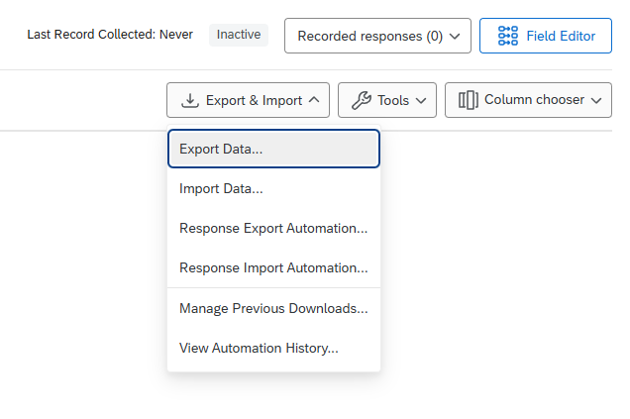
- Click the format you want to export the data as, then hit ‘Download’.
